David Youngberg
ECON 201—Montgomery College

Lecture 11: Personal Finance, DJIA, Globalization & Balance of Payments

- Reaction time
  - Suppose some favorable news came out for a company. How long would it take for the stock price to change?
    - A few seconds, depending on the nature of the information
  - Efficient market hypothesis (EMH)—prices of traded assets reflect all publicly available information
    - Note this doesn’t mean the market is always right. Just that when it’s wrong, there’s no public information to suggest it’s wrong.
    - If every tradable is valued fairly at all times, there’s little point to trade frequently.
  - Why do some people beat the market?
    - Luck. With so many gambling, by chance you’ll get a few that have won many, many, many times over
    - Insider trading. US Senators beat the stock market by an average of 12.3 percentage points (if the stock market’s value grows by 3%, Senators’ portfolio’s value grows by 15.3%). House Representatives beat it by 6% and corporate insiders by 7.4%. Note insider trading laws do not apply to Congress.
    - Psychology. People panic. They succumb to overconfidence, group think, bubbles, etc. Those who can keep their head can profit.
- Picking stocks
  - Diversify: buy lots of different kinds of stocks to limit risk to any one area (this is also sometimes referred to as hedging your bet).
    - Buy and hold—buying and holding stocks for the long run, regardless of what their short run fluctuations are.
  - Avoid high fees: because stock picking is a fool’s game, there’s no reason to pay a lot for people to do it. But if you’re doubtful of the EMH, maybe it’s worth it. Maybe.
  - Compound returns build wealth: A 4% annual rate of return means you will earn interest on the interest you earned in previous years. $100 becomes $104, then $108.16, then $112.49, then 116.99, etc. This supports a buy and hold strategy.
    - Rule of 70—Again, the Rule of 70 appears. To estimate how many periods it will take to double your money, divide seventy by your rate of return.
    - At 4% rate of return, you will double your money in 17.5 periods. Without compound interest, it would take 25 periods.
  - No Return Without Risk: Profit opportunities that are sure things are quickly bought up, reducing the return.
    - Risk-return trade-off—higher returns come at the price of higher risk
- Dow Jones Industrial Average
  - Started in 1896, the DJIA selected a dozen companies which the DJIA group felt captured the composition of the U.S. economy.
    - Original Components of the DJIA (1896)

Company | Industry
American Cotton Oil Company | Cotton products
American Sugar Company | Sugar products
American Tobacco Company | Tobacco products
Chicago Gas Company | Natural gas
Distilling & Cattle Feeding Company | Agricultural products
General Electric | Edison’s electric company
Laclede Gas Light Company | Gas lighting products
National Lead Company | Lead products
North American Company | Utilities
Tennessee Coal, Iron and Railroad Company | Steel and railroad
U.S. Leather Company | Industrial leather supplies
United States Rubber Company | Rubber products

  - The Dow has since expanded to thirty components. Note only one company is still on that list.
    - Current Components of the DJIA (As of 1/20/2014)

Company | Industry
3M | Diversified industrials
American Express | Consumer finance
Apple | Consumer Electronics
Boeing | Aerospace & Defense
Caterpillar | Construction & Mining Equipment
Chevron | Oil & Gas
Cisco Systems | Computer Networking
Coca-Cola | Beverages
DuPont | Commodity Chemicals
ExxonMobil | Integrated Oil & Gas
General Electric | Diversified Industrials
Goldman Sachs | Banking & Financial Services
The Home Depot | Home improvement retailers
Intel | Semiconductors
IBM | Computer Services
Johnson & Johnson | Pharmaceuticals
JPMorgan Chase | Banks
McDonald's | Fast food
Merck | Pharmaceuticals
Microsoft | Software
Nike | Apparel
Pfizer | Pharmaceuticals
Procter & Gamble | Consumer goods
Travelers | Insurance
UnitedHealth Group | Managed health care
United Technologies | Diversified industries
Verizon Communications | Telecoms
Visa | Consumer banking
Wal-Mart | Retailers
Walt Disney | Broadcasting & Entertainment

  - The DJIA tracks the stock price of each company and reports the average. When you hear what the Dow is, you’re hearing the average stock price.
$$Average= \frac{Sum of all stock prices}{number of stocks}$$

    - But wait! The DJIA, as of March 12, 2014, is over $16,000. No stock price in that list gets even close to that. What’s going on?
    - It’s because of stock splits.
  - Firms, especially ones successful enough to get on the DJIA, issue what are called stock splits—they issue one or two (or more) stocks to everyone who has one and the price of the stock drops proportionally. If you double the number of stocks, you halve the price. Triple the stocks and the price is one-third.
    - The key idea is that the company’s value doesn’t change.
    - The problem is, if we use the same denominator with this new lower price, we’d record a drop in value.
    - What does the DJIA do? They change the denominator.
  - The Dow Jones Industrial Average divisor is the denominator the DJIA uses to compensate for stock splits.
    - As of March 11, 2014, it’s 0.15571590501117
  - To find it, the DJIA looks at what the index was before the split and sets that number equal to an incomplete average equation.

$$Average before stock split= \frac{Sum of all new stock prices}{x}$$

  - By solving for x (the new divisor), it finds what it will be using until another stock split.
- Example
  - Consider two firms and their stock prices.
    - Alpha Corp $40
    - Beta Corp $60
  - An index of these two firms would be $50.
  - If Beta Corp splits its stock in three parts (tripling the number of stocks), what’s it’s new stock price?
    - $60 / 3 = $20
  - Now we solve for x:
$$\$50= \frac{\$40+\$20}{x}$$
$$x= \frac{\$60}{\$50}=1.2$$

    - The new divisor is 1.2; this index will use that instead of 2 when determining the average price. This will continue until another stock split.
- Final words
  - Here’s the thing about the DJIA: now that you know what it is, you can see it’s not as important as people treat it.
  - Yes, these firms are important. They are big players in the economy and if they have a problem, other firms probably have a problem as well.
- A trading game
  - Trade increases aggregate utility.
  - The Fundamental Theorem of Exchange—voluntary trade with complete information is always mutually beneficial.
    - Note this is not the same thing as equally beneficial.
    - Trade also encourages peace and understanding.
  - Mistakes surely happen but either the harm is small (a movie wasn’t all that good) or people make special effort to ensure they don’t make a mistake (research a new car, inspect a house, consult a critic).
- Barriers to Trade
  - Globalization—the process of countries being open to more foreign trade and investment.
  - We recognize trade is a wonderful; not only does it increase production (comparative advantage) but it also is good for the individuals who participate in it.
  - But the foreign producers who benefit have little political voice; the domestic producers who are harmed by trade have much more political pull.
  - Thus governments are prone to trade barriers (not an exhaustive list):
    - A tariff is a tax on imports. By making imports more expensive, governments help shield domestic production from competition.
    - An export subsidy is a subsidy for domestic production which, in turn, makes it cheaper on the world market. The United States heavily subsidizes its food (much to the anger of developing nations).
    - An import quota caps how much (either in quantity or in value) can be imported into a country over a specific period of time.
    - Nontariff barriers are regulations or bureaucratic barriers which make it more difficult to import. For example, Japan has strict inspection requirements on imported food. Supposedly this is to prevent the introduction of harmful insects but it is particularly strong.

- The trade deficit
  - Exports – Imports = NX (or the balance of trade).
  - The “deficit” is when imports > exports, or when NX is negative.
  - People are very concerned that the US’s NX is negative, seeing it as a sign of a weak economy. There are several things wrong with this view.
    - Trade deficits occur within countries.
    - People are buying things they want—utility is increasing.
    - The trade deficit is only part of the equation. This last point warrants further exploration.
- Balance of Payments (BoP)
  - All trade activity is captured in this equation: NX + CA = 0.
    - Where CA is the capital account, or the net flow of investment. Note that sometimes NX is called the current account, as in the flow of goods that currently exist, while the capital account speaks to the money used to create capital, the investment.
    - Note your book splits CA into a narrower version of capital account (debt forgiveness) and financial account (sale of financial assets).
  - But does it balance in practice? It does indeed! Note how one account is almost the perfect mirror of the other and the BoP always hovers around zero. (Source: BEA, International Economic Accounts).
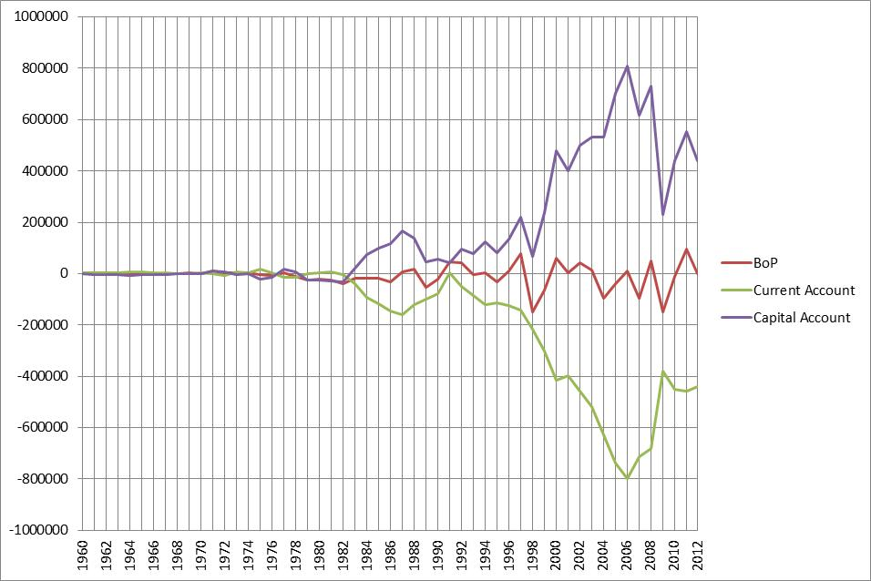
  - In a trade, the domestic country gave up their currency for goods and services. Abroad, this currency can have three different uses:
    - Import from the domestic country (NX increases).
    - Invest in the domestic country (CA increases).
    - Circulating it outside the domestic country.
  - The only reason people would accept currency that’s worthless in their country is because they think they can use in the country it is worth something.
    - Circulating it outside the domestic country is rare.
  - The trade deficit is not, repeat not, debt. It is merely an arbitrary distinction between the flow of goods and the flow of investment.
  - This harkens back to the distinction between increasing GDP and increasing wealth. A fall in NX reduces GDP but it doesn’t necessary mean people are poorer.

http://insidertrading.procon.org/view.answers.php?questionID=001034
http://wsj.com/mdc/public/page/2_3022-djiahourly.html

