David Youngberg
ECON 201—Montgomery College

Lecture 01: Introductory Economic Tools

- Economics: the study of optimality (or how to get the most out of life)
  - Microeconomics focuses on the actions of individuals, households, and firms in a single market.
  - Macroeconomics is concerned with the economy as a whole, dealing with big concepts such as inflation, growth, and employment.
    - Macroeconomics is built from microeconomic ideas; if you’ve had micro before, the beginning of this course will be familiar.
  - To begin: What is not scarce? (No scarcity, no markets.)
  - The importance of scarcity
    - Cost-benefit analysis—a process of weighing the total costs of an action against the benefits of that same action and proceeding if benefits exceed costs
    - This sort of analysis seems too obvious to need to be pointed out but it serves as a helpful guide. Certain policies or events carry so much emotion that we forget to weigh the costs against the benefits.
- Incentives matter
  - This is because people are rational—choosing the best action given their preferences and constraints.
    - Because incentives matter, choosing the right incentives changes everything. This has enormous implications for policy and economic development.
    - The institutions, the rules of the game, should align self interest with social interest.
  - Rationality matters because people have choices. People have choices because there is scarcity.
- Unintended consequences
  - When institutions are not aligned properly with incentives, you can get strange effects. You can even get the opposite of what you wanted.
  - In 2008, the Romania government provided vouchers to buy computers to every family below the poverty line. Economists Ofer Malamud and Cristian Pop-Eleches examine the effects.
    - First they noted that computer use among the poverty-stricken did increase (the red line is the poverty line).
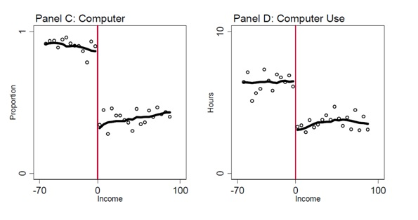
    - But they found that math, Romanian, and English scores all fell.
    - Why? Because they also found out that students just used their new computers for games.
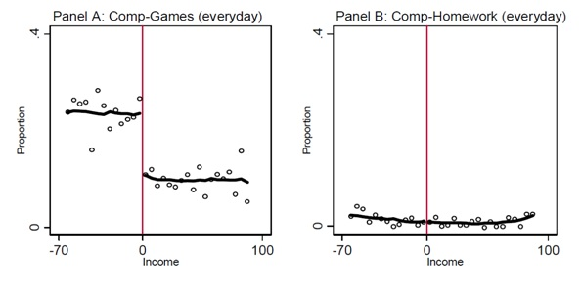
  - How would you have fixed this problem?
- So what?
  - Efficiency—Maximizing output with a given amount of input.
    - Also known as minimizing waste.
  - Efficiency seems like a dry, heartless concept but it isn’t.
    - By being able to do more with less, we can use what’s saved to do other things—in effect we lower our opportunity cost and do the things we would normally forgo.
    - These other things are not just consumer items. Innovation, art, education, meditation, music, socializing, and traveling are all things we can do.
    - Indeed the history of humanity includes more of these higher pursuits as people save the time and money to not just make these things but appreciate them. Efficiency helped bring about the works of Mozart, Shakespeare, Aristotle, and Confucius—people don’t ponder art and philosophy when they’re struggling to survive.
    - Greater wealth also opens the door for medicine, sanitation, a variety of food, safe streets, warm shelter, electricity, etc.
  - At the heart of this process is specialization—the process of individuals producing a narrow kind of output.
    - What’s nice about specialization is it allows people to be really good at a specific task. That increase in efficiency means the extra output can be traded for other items made by other specialists.
    - All things being equal, larger societies are wealthier as it allows greater specialization.
    - This theme plays into why economists tend to like free trade: it expands the boundaries of a society. Isolation is poverty. Just watch Naked and Afraid for an extreme example.
- Consider this diagram:
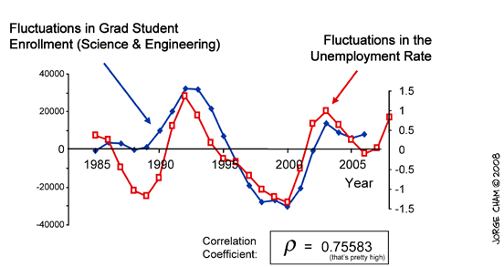
  - Trade-offs are everywhere: it is a consequence of choice. For everything you choose, there is something you must give up.
  - This is the opportunity cost—the net gain of the next best option.
    - Note this is net gain: include the costs as well as the benefits.
    - When the opportunity cost is high, that means you are sacrificing a lot; when it is low, you are sacrificing little.
    - In that way, they are costs in the truest sense.
- Applications
  - Do disasters make us wealthier?
  - Does war make us wealthier?
  - Does a draft make us wealthier?
  - Does job creation for the sake of job creation make us wealthier?
- The Marginal Revolution
  - The Diamond-Water Paradox
    - Water is critical for life and diamonds are not. Why is water so cheap and diamonds so dear?
  - The paradox was solved with the Marginal Revolution
    - Margin: the change in total something, each individual units of something
    - Marginal analysis: decisions are made on the margin; a little bit more or a little bit less
    - People put value on something based on marginal analysis
  - Diminishing Marginal Utility
    - Utility—economic lingo for satisfaction or benefit
    - Each additional unit—each marginal change—generates less and less utility (we call this diminishing marginal utility).
    - The first ice cream I eat is great, the second isn’t as good as the first, the third is even less, the fourth starts tasting disgusting
  - Oranges example
    - Suppose I hand you 12 oranges. What do you use them for and in what order?
Orange | Utility | Orange | Utility | Orange | Utility
1st | $20 | 5th | $16 | 9th | $12
2nd | $19 | 6th | $15 | 10th | $11
3rd | $18 | 7th | $14 | 11th | $10
4th | $17 | 8th | $13 | 12th | $9
    - Note that each item down the list would be worth less and less to you.
    - Now suppose I give 11 oranges instead. Do you divvy up the orange, reducing each activity by a twelfth or do you give up an option on your list? If so, what option do you give up?
  - Marginal utility
    - The value of one more gallon of water is very low but the value of one more diamond is quite high
    - Use the most valuable ends first, then go down the list

  - Marginal cost
    - Marginal cost follows the same pattern as marginal utility, it just goes in the opposite direction
      - Marginal cost increases (instead of decreases)
      - Start with the lowest cost (instead of the highest value)
  - Oranges example, cont.
    - Now suppose that I’m picking the oranges I’m handing you form a large tree. This time, I start with the lowest cost first.

Orange | Cost | Orange | Cost | Orange | Cost
1st | $8 | 5th | $12 | 9th | $16
2nd | $9 | 6th | $13 | 10th | $17
3rd | $10 | 7th | $14 | 11th | $18
4th | $11 | 8th | $15 | 12th | $19
- Synthesis
  - Suppose instead of giving or handing you the oranges, I sell you them.
    - For the first orange, it costs me $8 to get the orange and you are willing to pay $20. Thus there are many opportunities for us to agree on price
    - For the next orange, it costs me $9 and you value it at $19. Again, there are many opportunities to agree on a price (though there are slightly fewer).
    - This continues until the 7th orange, where the only price we can agree on is $14.
    - Note if we try to exchange an 8th orange, we wouldn’t agree on a price.
Orange | Utility | Cost | Orange | Utility | Cost
1st | $20 | $8 | 7th | $14 | $14
2nd | $19 | $9 | 8th | $13 | $15
3rd | $18 | $10 | 9th | $12 | $16
4th | $17 | $11 | 10th | $11 | $17
5th | $16 | $12 | 11th | $10 | $18
6th | $15 | $13 | 12th | $9 | $19

  - The key idea behind marginal decision making is that people will engage in an action until marginal benefit equals marginal cost
  - Again, the miracle of prices appears. If the price rises, then you will forgo your least valuable action. This socially desirable result emerges without a central planner. Prices solve problems.

