David Youngberg
ECON 201—Montgomery College

Lecture 12: Income Inequality & Immigration

- Of Pie
  - When economists talk of income inequality we typically talk in terms of pie: our metaphor for income.
    - “Equal slices of pie” implies an equal amount of income.
    - The “size of pie” refers to how much total income there is.
  - The metaphor is quite useful: imagine we’re eating pie together and you cut yourself a very big slice, leaving less for everyone else. If you eat that whole big slice of pie, it might start out very satisfying but that joy is quite dulled at the end.
    - In other words, there are diminishing marginal returns.
  - Meanwhile, everyone else only has a little bit of pie. We’d like some more. Because we’ve had so little, a bit more would make us a lot happier.
    - If you take less, there is a small decrease in overall satisfaction.
    - If we take what you gave up, there is a much larger increase in satisfaction.
    - Reallocation of pie makes the group happier; this is why you typically split a pizza (pie) evenly. Equal shares maximizes satisfaction.
  - But suppose the pie isn’t given to us; we made it together. Also suppose you worked very hard to make the pie while the rest of us slacked off. If we all take equal slices, you might not want to work as hard when we make pie again because you won’t be compensated fairly.
    - As a result, the size of the pie shrinks; not enough is being done to make it large.
  - Thus the essential question: how do you slice the pie when the more equal the slices, the smaller the pie?
    - This is called the equality-efficiency trade-off.
- Compensating differentials
  - Because high wages can induce people to enter a market, wages rise if there are few people willing to enter a market.
    - For example, consider malpractice suits. Doctors are regularly sued for alleged incompetence or poor care, even if these suits are frivolous.
    - To combat the threat of suits, doctors increasingly do a lot of paperwork and extra tests. They spend less time interacting with patients and more time doing rather dull work.
    - As a result, the cost of being a doctor has increased, or the supply curve shifts to the left. In order to keep up the same number of doctors, you have to pay them.
  - Fun jobs are jobs with lots of people interested in doing them. Thus the wage for that job falls.
  - And less fun jobs means there are few people willing to do them. Thus the wage for that job rises.
  - A compensating differential is a difference in wages that offsets differences in working conditions.
    - Thus, dangerous jobs pay more than less dangerous jobs.
    - Boring jobs pay more than exciting jobs.
    - Jobs with lots of flexibility pay less than jobs with little flexibility.
  - Due to compensating differentials, all jobs should be equally desirable.
- Why is there income inequality?
  - There’s a variety of reasons for income inequality. Some of them are fair reasons and some are not. Some reasons include:
    - Ability—Some people are more productive than others. This could manifest as intelligence, grit, physique, diligence, or other desirable social, physical, or mental traits.
    - Education/Experience—You know this well; more education increases earning potential. We’ve talked about how some of that is skill building and some of it is signaling (which is then really a reference to the previous point).
    - Preferences/Risks—Dangerous jobs get paid more (to compensate workers for the danger they submit to). Others choose jobs with a lot of leisure time or work in the household (say, raising children) which generates no income.
    - Cronyism—Some companies/people make money not because they are productive but because they’ve restricted competition and/or garnered political favors.
    - Luck—Some people are born lucky; they have well-off parents who can help them build the human capital which lets them get a good job. Others are unlucky: they might be stricken with a disease or started off in a low-income family which interfered with their ability to make themselves more productive.
      - The diminished incentive effect on redistributing income based on this criterion makes the “shrinking pie” danger less likely.
    - Discrimination—Many individuals have less income because of bigotry including bigotry based on race, gender, creed, sexual orientation, and gender identity. But it’s very hard to detect; we’ll have to discuss this more to see.
  - Consider the pay gap between men and women which is often cited as 77 cents on dollar. In other words, for every dollar men make, women make 77 cents.
  - This is the result of a crude averages. It is deceptive because it assumes men and women have the same kinds of jobs. They don’t.
    - Men are more likely to work in the sciences, finance, and engineering.
    - Men are more likely to work dangerous jobs.
    - Men tend to work longer hours.
    - Women are less likely to negotiate a higher salary when they get hired.
    - Women are more likely to leave the labor force for long periods of time.
    - Women are more likely to seek jobs with flexible hours.
  - When adjusted for these variables, gender discrimination accounts for no more than 5% of the pay gap. There is certainly still sexism in the market place and it seems likely it accounts for some income inequality. But not much.
- Measuring inequality
  - Imagine we’re going to add up everyone’s income starting with the lowest and ending with the highest. In a perfectly equal world, the bottom 20% of families will have 20% of income as the top 20% of families has 20% of income. This equal world is represented by a 45-degree line.
  - The actual distribution is the Lorenz Curve. Like the 45-degree line, it a cumulative distribution. In this example, the top 20% of earners (100 – 80) make 60% of the total income (100 – 40).
Percentage of Families
0
20
40
60
80
100
100
Percentage of Income
80
60
40
20
0
Lorenz Curve
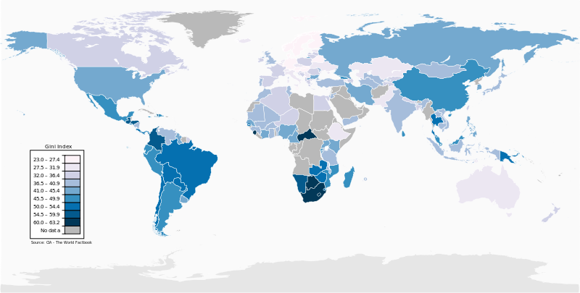
  - If you take the area between the 45-degree line and the Lorenz Curve and divide it by the total area under the 45-degree line, you get what’s called the Gini Ratio.
    - Higher ratios mean more inequality, lower ones mean less inequality.
    - It’s sometimes multiplied by 100 for ease of interpretation.
    - Here’s a world map of Gini ratios. Darker countries mean higher Gini ratios.
- The Incentive to Move
  - As we’ve discussed, income and income equality varies tremendously across countries.
  - Even though uprooting yourself and your family to move to a strange land with an unfamiliar language would be very costly, the benefits are large enough to encourage millions to immigrate to other countries.
  - While there is no doubt the move is good for the movers, the question becomes how easy it should be to move and that answer depends on how immigration—especially mass immigration—impacts the economy people are migrating to.
- Against immigration
- Wages will fall as supply shifts right.
- Immigration makes it harder for citizens to find a job.
- Strain on government services, such as hospitals, schools, and police.
- National security threat: terrorism, crime, and disease.
- In favor of immigration
- Lower wages mean lower prices which raise living standards.
- Open borders increases the tax base to pay for government services.
- More people allow for greater specialization and increased efficiency.
- More people mean demand shifts right, too.
- Evaluation
- Many of these are empirical questions; it requires evidence to figure out who’s right.
- To properly untangle all the effects, we need a natural experiment: a sudden and isolated increase in immigration. That way we can compare before and after with the place that received the immigration with a similar place that didn’t.
- One Study: Mariel boatlift
    - Following a sudden economic downturn, 125,000 Cubans left via boat from the harbor at Mariel and arrived in Florida between April and October 1980.
    - Economist David Card examined the results, focusing on Miami. Miami’s labor force increased 7% with an even larger increase in low-skilled workers.
    - Yet there were virtually no wage and unemployment effects in low-skilled workers. Demand shifted out, too.
- Becker’s Solution
- One way to approach this question comes from Gary Becker, the 1992 Nobel Laureate in Economics.
- Becker notes that most of the gain goes to the immigrant. Why not have the immigrate pay for the right to enter the country?
- An entrance fee of, say, $50,000 would ensure only the most productive immigrants enter the country. These immigrants would tend to be highly educated, non-violent, and healthy.
    - The fee could be paid over the course of several years or could be paid via much like how student loans work.
    - It could also be used to cut other taxes and/or pay for more social services.
- Illegal immigrants would have the incentive to legalize their status. By opting into paying the fee to become documented, they could apply for a wider variety of jobs, improving job matching and reducing structural unemployment.

http://www.census.gov/prod/2013pubs/p60-245.pdf page 7
http://online.wsj.com/news/articles/SB10001424052702303532704579483752909957472
http://www.stanford.edu/group/scspi/_media/pdf/Classic_Media/Card_1990_Immigration.pdf
http://www.iea.org.uk/sites/default/files/publications/files/IEA%20Challenge%20of%20Immigration%20web.pdf
Becker won his Nobel Prize for his work in applying economics to unconventional areas such as dating, discrimination, and crime. Becker argued people are motivated by much more than money and we can use the same economic tools used in conventional markets to understand other areas. Freakonomics is one of the intellectual children of Becker’s work. He died May 3, 2014.

