David Youngberg
ECON 201—Montgomery College

Lecture 06: Exchange Rates & Signaling Theory

- Exchange rates
  - Think of a currency as the right to participate in a country’s economy.
    - A strong currency is high relative to others. Thus its exports are relatively more expensive. At the same time, the strong currency tends to attract foreign investment.
    - A weak currency is low relative to others. Thus it tends to be less attractive to foreign investors. At the same time, its exports are relatively less expensive.
  - When a currency becomes stronger, it appreciates. When it becomes weaker, it depreciates.
- Law of One Price
  - Suppose, at current exchange rates, rugs cost $10 in one country and $200 in another country. What do you do?
    - This causes the cheap rugs to be more expensive and the expensive rugs to be cheaper.
    - This should continue until the prices are equal (or nearly equal, since you have to pay to ship the rugs).
    - Thus the law of one price—when there are no barriers to trade, the price of a good or service should be the same everywhere.
  - All things being equal…
    - The currency with the cheaper rugs will appreciate and
    - The currency with the expensive rugs will depreciate.
- Purchasing Power Parity
  - In reality, though, barriers to trade exist. There are transportation costs. There are tariffs and customs. There is spoilage. Prices for many products vary widely.
    - By looking at many goods and services, you can get a “big picture” view.
    - However, quality of goods and services changes from country to country, biasing the index.
    - Thus the purchasing power parity (PPP)—technique used to determine the relative value of different currencies.
  - Like the law of one price, PPP has a prediction (called purchasing power parity theory): exchange rates between any two currencies will adjust to reflect differences in the price levels of various currencies.
  - Consider the Big Mac Index. Big Macs are famously the same everywhere. That uniform quality helps judge purchasing power and, in theory, can be used to predict how prices will adjust.
    - In July 2015, a Big Mac in the U.S. cost on average $4.79.
    - At the same time, using July 2015 exchange rates, it cost…
      - $1.88 in Russia, suggesting the Russian rouble is undervalued; it should appreciate soon.
      - $6.82 in Switzerland, suggesting the Swiss franc is overvalued; it should depreciate soon.
      - $1.83 in India, suggesting the Indian rupee is undervalued; should it appreciate soon?
    - The Big Mac Index is by no means perfect—it is just one product, after all, but it’s a useful way to help think about PPP and the law of one price.
- Floating Exchange Rate Regime
  - In a floating exchange rate regime, market forces determine how rates are priced. There’s little to it beyond that but since the market’s doing all the work, it seems like a good time to explore how various market forces change the exchange rate.
  - The purchasing power parity influences the exchange rate. The more a currency can buy, the more the currency is worth.
  - It’s useful to remember supply and demand to help you remember how currency prices change. There is a supply of currency and there is a demand for that currency.
  - The following also changes the price of a currency. For simplicity purposes, this will always be explained in terms of a domestic currency.
    - Note all of these changes are relative. That’s because all currencies are priced in terms of all other currencies. If all countries have the same amount of inflation, no currency has become less valuable compared to all other currencies.

A change in the relative… | Appreciates | Depreciates | Explanation for Appreciation
Domestic demand for imports | ↓ | ↑ | If fewer people demand imports, fewer units of domestic currency will be on the currency exchange market (because fewer people are willing to give it up). Supply shifts up/left.
Foreign demand for exports | ↑ | ↓ | If more people want the domestic country’s goods, more people will want that country’s currency. Demand shifts up/right.
Domestic productivity | ↑ | ↓ | If the domestic country becomes more productive, more people will want to participate in that economy (perhaps through investment). Demand shifts up/right.
Domestic interest rate | ↑ | ↓ | If the domestic interest rate is higher, more people will want to participate in that economy (perhaps through investment). Demand shifts up/right.
Domestic price level | ↓ | ↑ | Note that a decrease in the price level is called deflation; an increase is called inflation. What happens with demand and supply depends on why inflation or deflation occurred.  - If it was due to a fall in the money supply, there are fewer units of currency so supply shifts up/left.  - If it was because there’s an expansion in the economy, it’s because each unit has become more valuable so demand shifts up/right.

- Fixed Exchange Rate Regime
  - A fixed rate first focuses on an “anchor currency” to be pegged to. China, for example, once kept their rate at about 8 yuan to the dollar.
  - The domestic government (the central bank) holds foreign currency, drawing a distinction between the private sector capital account and the government’s capital account, often called the official reserve transactions balance (the government’s international reserves).
  - It is with this reserve of foreign currency that fixed exchange rate regimes manipulate the market.
  - Suppose China as a major manufacturer suddenly looks less appealing to the world at large, putting downward pressure on the yuan.
    - At eight to the dollar, the yuan is currently overvalued.
    - To defend the currency, the government buys yuan with their international reserves (causing them to shrink).
    - In effect, the government simulates additional demand for a currency people are losing interest in.
  - Now suppose China suddenly looks more appealing as an economy to the world at large, putting upward pressure on the yuan.
    - At eight to the dollar, the yuan is currently undervalued.
    - To defend the currency, the government sells yuan for additional international reserves (causing them to grow).
    - In effect, the government simulates a lack of demand for a currency people are gaining interest in.
- The value of a degree
  - There is ample evidence that having a college degree not only increases your average salary, but also decreases the chance of long-term unemployment.

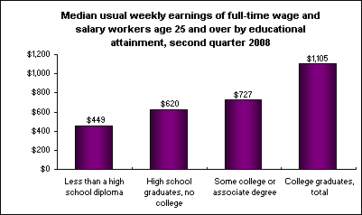
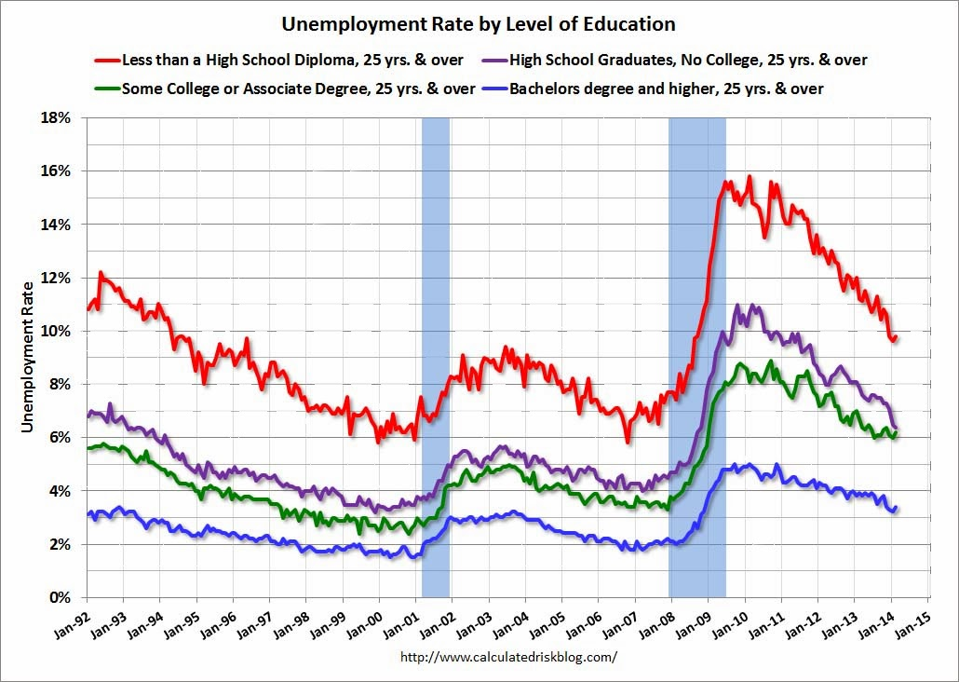
  - Why this distinction? There are two major theories as to why earning a college degree increases your attractiveness to employers.
- Human Capital
- This first is the most intuitive: skills. In college, you learn things that are practical in the real world. Armed with this knowledge (and with the proof that you’ve learned it…i.e. a degree), more people want to hire you.
- This is the human capital theory, human capital being the “tools of the mind:” reasoning skills, writing skills, technical skills, time management skills. It also includes experience, intelligence, and anything else in someone’s mind which makes them more productive.
    - Notice how this theory connects with MPL.
- The human capital theory suggests your major matters. In May of 2011, The Chronicle of Higher Education looked at Census data to determine how income changes with major. Indeed, it matters a lot. Here is a sample of various median earnings:
    - Petroleum Engineering: $120,000
    - Pharmaceutical Sciences: $105,000
    - Mathematics and Computer Science: $98,000
    - Economics: $70,000
    - Accounting: $63,000
    - Microbiology: $60,000
    - History: $50,000
    - Music: $42,000
    - Early Childhood Education: $36,000
    - Counseling Psychology: $29,000
- It’s important to remember at this time that compensating differentials also play a role here. As your textbook reminds you, for most people music is more fun than accounting. Still, it is reasonable to believe that some of this difference comes from differences in skills.
- Over time, the value of a college degree relative to only a high school degree has risen which might suggest human capital is becoming more important.
- Signaling
- The human capital theory isn’t perfect and has difficulty in explaining some data. For example, using the same information about earnings by major, foreign languages has the same median income as philosophy ($48,000). There is a clear practical skill to one, but not the other.
- Moreover, many things you learn in college you will not use in the real world. For example, you will never have to so much of the modeling we will do later in this class (unless you go on to teach economics!). So what’s going on?
- A signal is an action or observable trait which demonstrates you have some unobservable trait. It is the natural response to the adage: talk is cheap.
- Signaling works when both of two things hold:
    - Sending the signal is easy when you have the trait.
    - Sending the signal is hard when you lack the trait.
- The signaling theory of education argues that education signals competence, intelligence, diligence, and other traits which employers find valuable.
    - If you are smart and hard working, getting a college degree is easy. If you are stupid or lazy, getting a college degree is hard.
    - The same goes for grades, which is why your grades in even “blow off” classes matter.
- Signaling solves our philosophy/language major paradox.
    - Philosophy requires a lot of reading, thinking, and logic skills. It is hard for most people.
    - Languages are also difficult to learn, but for more individuals than philosophy, they come naturally. Other individuals grew up learning multiple languages.
    - Thus philosophy is impractical, but hard for everyone. Languages are useful, but much easier (if you are majoring in a modern language, you probably have an easier time than most at learning a new language).
- Signaling can also solve why your major matters: some majors are harder to learn than others.
- Signaling Extensions
- Signaling has a lot of applications beyond educational value. In fact it’s one of the most useful ideas in economics.
- Interviews. Dressing nicely and being organized signals that you are serious about the position, that you can act in a professional manner, and that you have valuable skills like attention to detail.
- Dating. Looking good and being funny signals that you take the date seriously, are genuinely interested, and are worth being around.
- Credit Score. Paying off your debt quickly and keeping a low balance on your credit card signals you are fiscally responsible and thus worthy of a low interest rate if you need a loan.

Graphs from http://www.bls.gov/opub/ted/2008/jul/wk3/art01.htm and calculatedriskblog.com, respectively.
http://chronicle.com/article/Median-Earnings-by-Major-and/127604/

