David Youngberg
Acct/Busa/Econ 222—Bethany College

Lecture 02: Being Inductive

- Types of economics
  - Normative economics—expresses conclusions using value judgments.
    - Also known as “what ought to be.”
  - Positive economics—expresses conclusions using information and logic.
    - Also known as “what is.”
- Types of reasoning
  - Inductive—drawing conclusions from a limited set of facts; it does not claim to be conclusive. The results of inductive reasoning are hypothesis.
    - Evidence leads to a hypothesis. (We ask “Why is this true?”)
    - It goes from specific clues to a general idea.
  - Deduction—form of argument that asserts to be conclusive; it is the mechanical result of a given set of premises. The results of deductive reasoning are facts (given certain assumptions).
    - A hypothesis is treated as a fact and leads to conclusions. (We note if this is true, then other things should also be true. Are those other things true as well, lending support to our hypothesis?)
    - It goes from a general idea to specific conclusions.
    - A valid argument is one that follows logically from premise to conclusion.
    - A sound argument is a valid argument with true assumptions.
  - With the rise of computation, the interest of empirical work (inductive reasoning) is on the rise. Some think this diminishes the value of theoretical work (deductive reasoning) but it actually enhances it.
    - Theoretical work is using math with a set of assumptions to draw interesting conclusions.
    - These results are then used to guide empirical work.
    - For example, economists (starting with Keynes) theorized that increasing government spending will speed up recovery.
    - Other economists use economic data to induce a conclusion, resulting in a “Keynesian multiplier” estimation between 0.8 and 1.2 (or, for every $1 the government spends, GDP will increase anywhere from $0.80 to $1.20).
  - Theory does not always inform empirical work—sometimes it goes the other way around. Economists Card and Krueger wrote an empirical paper about the effect of a minimum wage law. Contrary to conventional theory, they found that an increase in the minimum wage caused less unemployment. They then developed a theoretical model to try to explain why.
- Data Basics
  - To be inductive, you’ll have to look at data. In econometrics, there are three different types of data.
    - Cross-sectional—each observation is an additional individual, firm, etc. with information at a point in time. It is also known as a random sample.
    - Panel—a series of cross-sectionals with some fundamental difference between them, such as different states, companies, or majors.
    - Time series—each observation is in a separate time period. These are not random samples and so trends and seasonality become an issue.
- Normal Distribution
  - Normal distribution—this common type of distribution is bell-shaped. The mean has the most observations, diminishing in both directions and ending with two “tails” of observations. Its mean equals its median equals its mode. It can be used to infer about two populations’ mean.
    - Of course, you should already be very familiar with this type of distribution.
    - Carl Fredrich Gauss goes to the fair.
- Data and dispersion
  - Standard deviation—expressed in the same units of data and describes the level of variation of the data.
    - For small samples, standard deviation is calculated as such:
$$σ=\sqrt{\frac{1}{N-1}\sum_{i=1}^{N}{{\left(x_{i}-\overline{x}\right)}^{2}}}$$

  - You might wonder why you should learn the calculation for standard deviation if computers can do it for you. This graph (the distribution of grade from all my classes in the fall of 2011) is why: sometimes you get summary data and can’t get a computer to do it all for you. But we can use the equation to determine standard deviation.
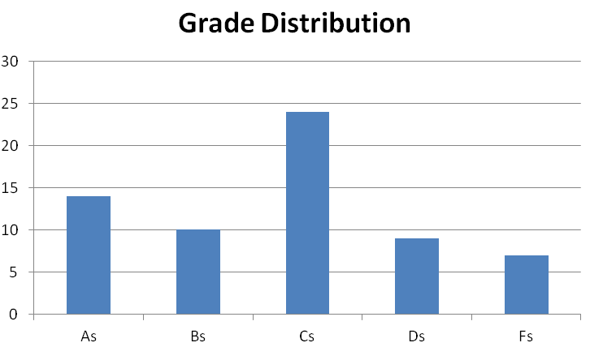
    - Let As=4, Bs=3, Cs=2, Ds=1, Fs=0
    - N = 14+10+24+9+7 = 55
    - The sum is 14(4) + 10(3) + 24(2) + 9(1) + 7(0) = 143
    - The average is 143/55 = 2.6
    - Now we calculate: 14 (4 – 2.6)² + 10 (3 – 2.6)² + 24 (2 – 2.6)² + 9 (1 – 2.6)² + 7 (0 – 2.6)² = 27.44 + 1.60 + 8.64 + 23.04 + 47.32 = 108.04
    - Now we divide the result by 54 (one minus the sample size) and take the square root: $\sqrt{{108.04}/{54}}=1.4$
  - There are other measures of dispersion—variance, standard error, confidence interval, kurtosis, and skewness. In theory, you should remember this from Statistics I. If you don’t, we’ll cover it briefly now.
  - Variance—the standard deviation squared
  - Standard error—the standard deviation divided by the square root of the sample size. It is used to calculate the confidence level.
  - Confidence level—If we were to take 100 samples, X of those sample means will be between this mean, plus and minus the indicated value, where X is the confidence level. (e.g. 90%, or 90, which is the default value in Excel)
  - Skewness—measurement of distribution symmetry
    - A positive skewness means there is a long tail (few extreme values) on the right. Mean is greater than median: e.g salary
    - A negative skewness means there is a long tail (few extreme values) on the left. Mean is less than median: e.g. test score
    - Symmetric means the tails are equally disperse. Mean equals median: e.g. height.
  - Kurtosis—measurement of the peakedness of the distribution
    - If negative, the peak is flatter than normal.
    - If positive, the peak is sharper than normal.
    - If zero, the peak resembles that of a normal distribution.
- The Geometric Mean
  - So far most of what we’ve talked about should seem at least somewhat familiar, especially averages which we talked about last class.
  - But even when you want a mean, you might not be using the right mean.
    - The arithmetic mean is the mean you’re familiar with: add up the values and divide by the number of observations. It’s useful for most things and is the default mean people use.
    - The geometric mean is different: multiply the averages and then take the nth root of the result, where n is the number of observations. This mean is used for finding averages of rates, such as growth rates.
  - Why is there a separate mean? Most of data stands on its own but growth rates are multiplied with other data.
    - If inflation is an average of 1% a year then a $5.00 bag of chips will cost ($5.00)(1.01) = $5.05 next year.
  - Suppose sales grew by 9% last year and 1% this year. Also suppose that sales were $100,000 at the start.
    - Thus they are now ($100,000)(1.09)(1.01) = $110,090.
    - But if you took the arithmetic mean, you’d think the average is 5%. So check it: ($100,000)(1.05)(1.05) = __________
  - So we just multiply 0.01 and 0.09 and then take the square root? Easy: that’s 0.03. But is that right.
    - Test it: ($100,000)(1.03)(1.03) = __________
  - The reason is when you use growth rates you add one before you multiply. If we do that here—add one to the growth rate and then subtract one after we’ve taken the nth root—we’ll correct for all the problems.
    - So now, multiply 1.01 and 1.09 (=1.1009) and take the square root (=1.049238).
    - Then subtract one to get a growth rate of about 4.924%. Not this is slightly less than our arithmetic mean.
    - Now we check: ($100,000)(1.04924)(1.04924) = __________

Lab Section

- Chapter 3
- Chapter 4
- Homework
  - Chapter 3: 4, 6, 8, 10, 11
  - Chapter 4: 3, 4

For more information on this topic, listen to this podcast: http://www.econtalk.org/archives/2011/10/ramey_on_stimul.html

