David Youngberg
Econ 280—Bethany College

Lecture 20: Outsourcing, Offshoring, and the Law of One Price

- Exchange rates
  - Think of a currency as the right to participate in a country’s economy.
    - A strong currency is high relative to others. Thus its exports are relatively more expensive. At the same time, the strong currency tends to attract foreign investment.
    - A weak currency is low relative to others. Thus it tends to be less attractive to foreign investors. At the same time, its exports are relatively less expensive.
  - When a currency becomes stronger, it appreciates. When it becomes weaker, it depreciates.
- Purchasing Power Parity
  - Simply knowing how much of one currency you can get for another doesn’t tell you the full story. You must ask what you can buy.
    - For example, until recently 60 US cents would get you 1,000,000 Turkish lira. Sounds like a lot until you realize that much lira would buy you one ferry ride across the Bosporus.
  - The purchasing power parity (PPP) is one reason why exchange rates are as they are. Because it took a million lira to cross the Bosporus, the lira was cheap on the international market.
  - Another way to judge how much a currency can buy is the Big Mac Index, a form of the PPP.
    - The PPP is calculated using the price of a common basket of goods in each country. However, quality of goods changes from country to country, biasing the index.
    - The Big Mac, on the other hand, is completely consistent no matter where you go and so the Economist routinely (and half jokingly) publishes the “Big Mac Index.” However, cultural differences, trade laws, taxes, and other notions distort this version of the more generally used PPP.

- Law of One Price
  - The PPP and exchanges rates naturally lead to the law of one price—prices between identical products in different countries will converge, assuming transportation costs are low.
  - The intuition works much like basic economics. If two firms produce the same good, but one’s twice as expensive, market forces will pull the two prices together.
  - The only difference here is that since we are looking at both different prices and different currencies, we must consult two different sources (the PPP and the exchange rate, respectively).
  - The law of one price is not an instantaneous notion. Prices converge over time, but not all at once. Transportation costs are also often high, though for some goods it has become virtually nothing thanks to information technology.
- Divvying out the Work
  - Outsourcing—Transferring work from inside a firm to outside of it.
    - Note that outsourcing doesn’t mean the work is going outside of the country the firm is located in. Work can be outsourced to a freelancer who lived across the street.
    - Work that goes out of the country is usually called offshoring, though such work can remain inside the firm.
  - Outsourcing and offshoring are used interchangeably, despite their differences. Since outsourcing’s main criticism comes from the concern that some outsourcing is also offshored, I refer to that particular case—offshored and outsourced—when I refer to outsourcing.
  - Thanks to information technology, lots of jobs can be outsourced such as legal consulting, telemarketing, customer support, proofreading, and component construction.
  - But most jobs, even now, cannot efficiently be outsourced. The need for face-to-face communication, quality control, and other issues make it difficult or expensive to outsource. Recently, toys made in China containing lead paint made headlines. This was the result of poor quality control measures on the part of companies outsourcing.
  - The extent of the market
    - Outsourcing is a manifestation of the power of the division of labor. Technology and low trade barriers extend the reach of market activity.
  - Outsourcing means that the optimal firm size is shrinking. (Remember theory of the firm.) Wages might fall so the transaction costs are worth the expense, or transaction costs themselves might fall.
- Sweatshop
  - While outsourcing enriches wealth, some are concerned about the worker conditions that arise from the outsourcing.
  - There is no easy definition of sweatshop but consensus is that the working conditions are harsh and the wages are low. But what is “harsh” or “low” is a relative term.
    - For example, many people in developing countries leave the farm to work in factories. By Western standards, the conditions are harsh. But they are far more favorable than the working conditions of a farm in a developing country.
    - While the wages are low by our standards, they aren’t by the country’s. For example, Kathy Lee Gifford received criticism for paying only $3.10 a day for Honduran workers. But half earn $2 a day and many earn only $1.
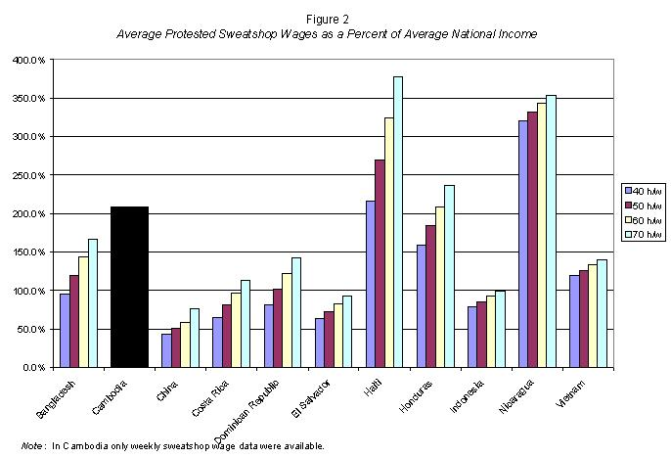
  - But the real evidence comes from people’s actions. Workers routinely line up for these jobs. They uproot their lives from them.
  - Ironically, pushes to improve wages and labor conditions diminish the reason for firms to provide these jobs, jobs which are the workers’ best option.

In 2005, Turkey revalued their currency, effectively slicing off many zeros. So far the new lira looks pretty stable and has not yet fallen victim the same hyperinflation its namesake experienced.
http://www.econlib.org/library/Columns/y2008/Powellsweatshops.html

